**SEATWORK**

**(Midterm)**

**NAME: BARROZO, ELYON JOHN S.**

**COURSE/SECTION: CPE 406/CPE42FA1**

**Instructions:**

Insert all the screenshots in each of the questions. Create a “Midterm” repo. Update your “Midterm” repo with a commit details of “SW Mditerm - <FULLNAME> <DATE>”. Submit your GITHUB Account Name together with the screenshot of our successful GIT PUSH thru email ([alvinsarragaalon@hotmail.com](mailto:alvinsarragaalon@hotmail.com)) with a subject format of “CPE 406 SW Midterm - <FULLNAME> <DATE>”

**Task 1 using IF**

Extract the subset of rows of the data frame where Ozone values are above 25 and Temp values are above 70. What is the mean of Wind in this subset?





## Task 2 using FOR LOOP

What is the mean of "Temp" when "Month" is equal to 9 and “Day” is equal to 8?

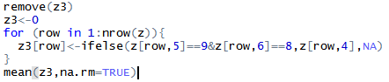



## Task 3 using While

What was the minimum ozone value in each of the month (i.e. Month = 5)??

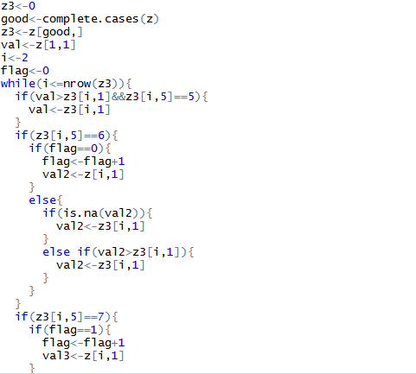

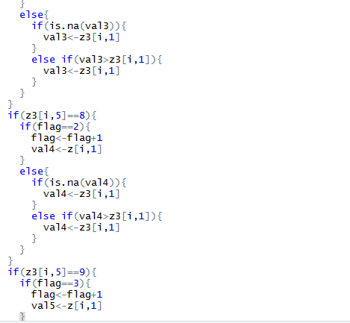

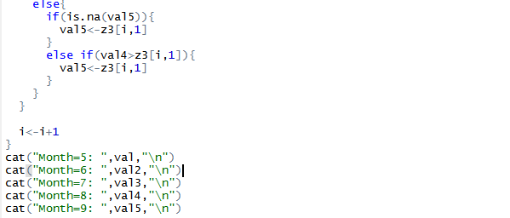

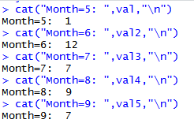

## Task 4 using Repeat, Break, Next

Convert Task 1, Task2, and Task 3 questions using Repeat – Break

Task1

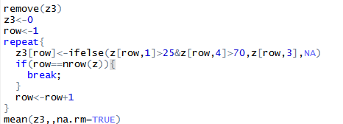



Task2

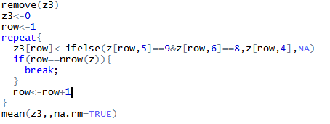



Task3

